**Assignment 8**

**Performance**

**Web Technologies MSIS517L**

Screenshots –

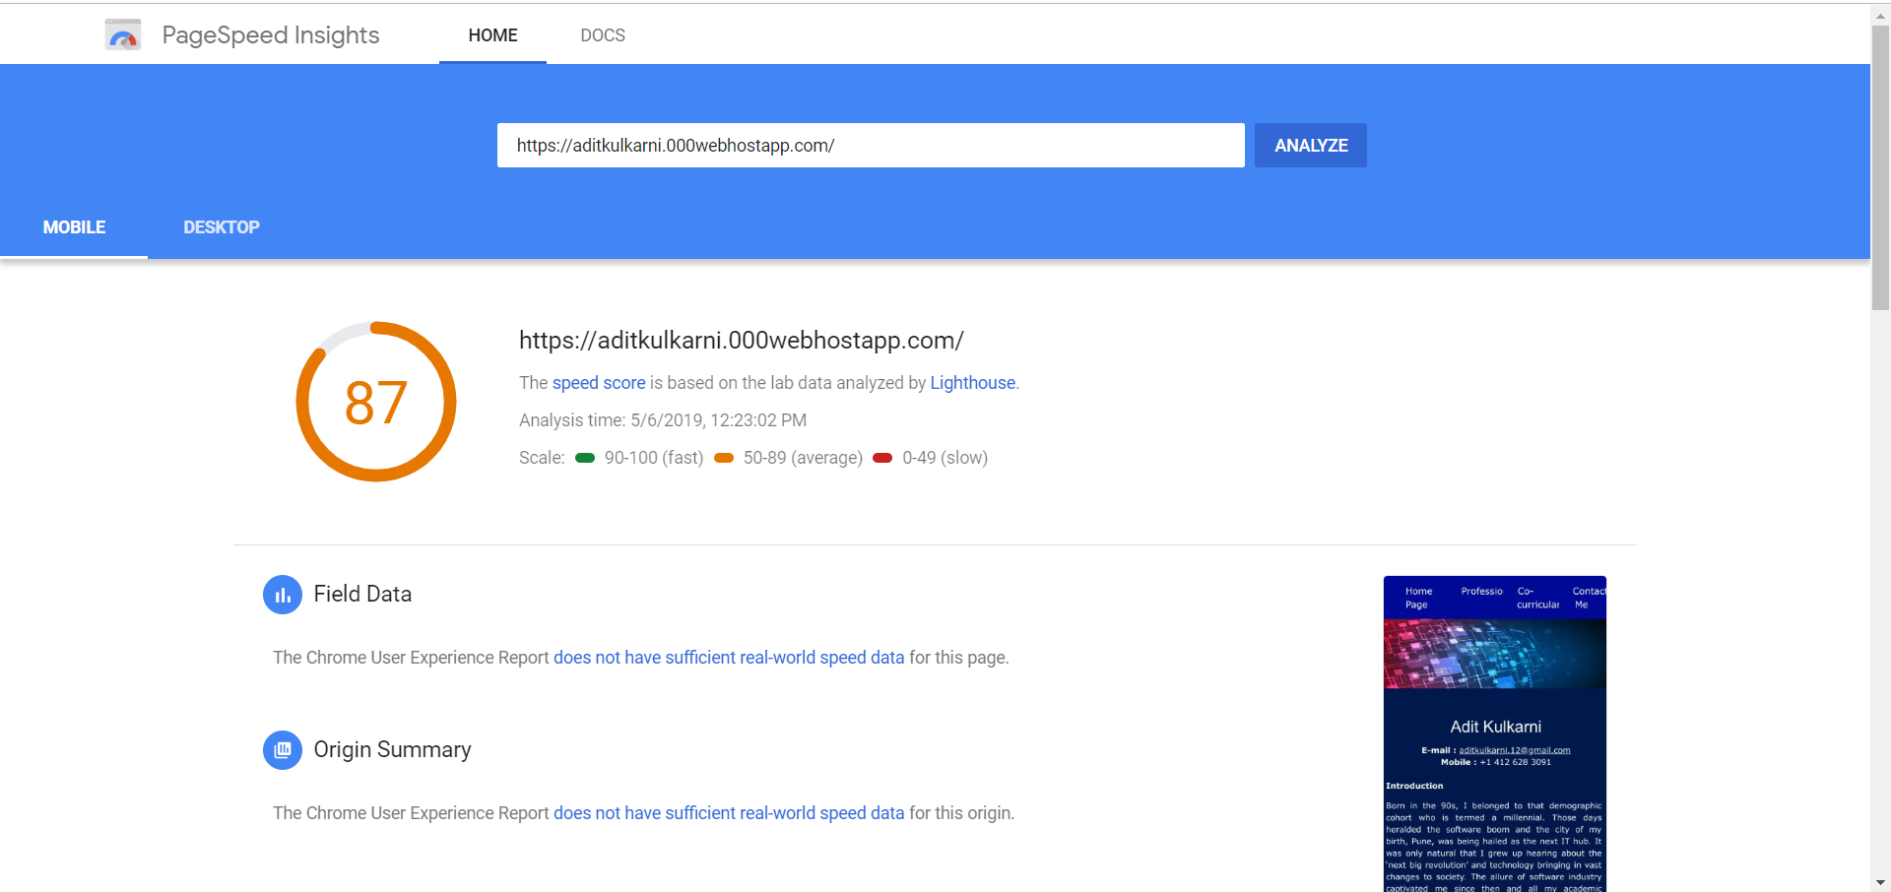

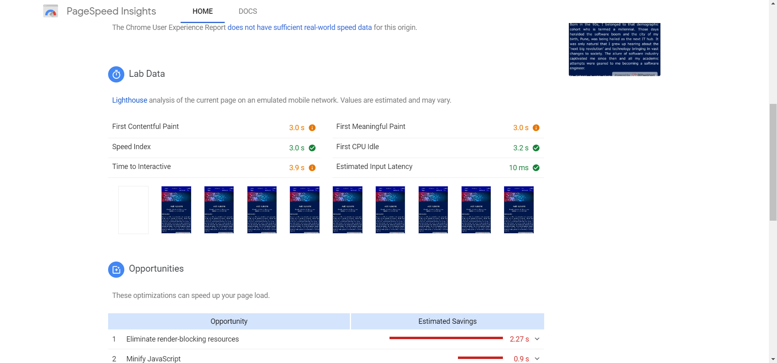

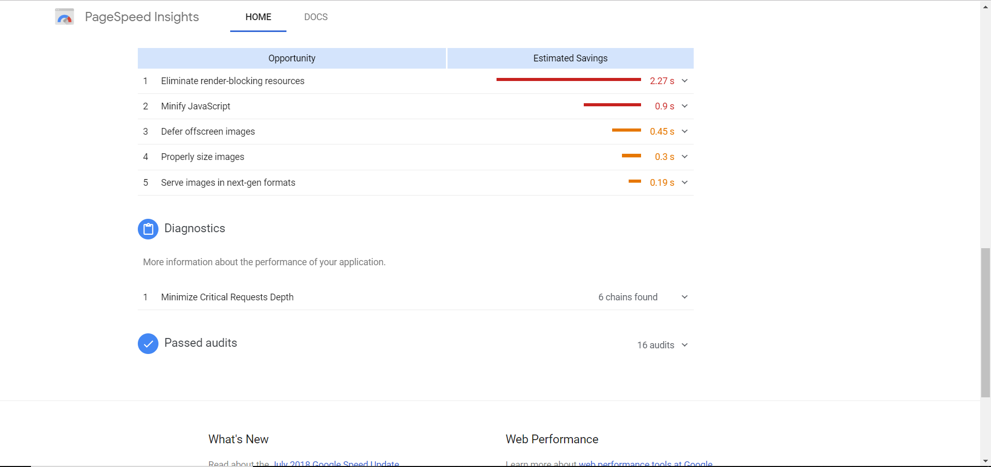

Developer Tools Screenshots –

Home Page

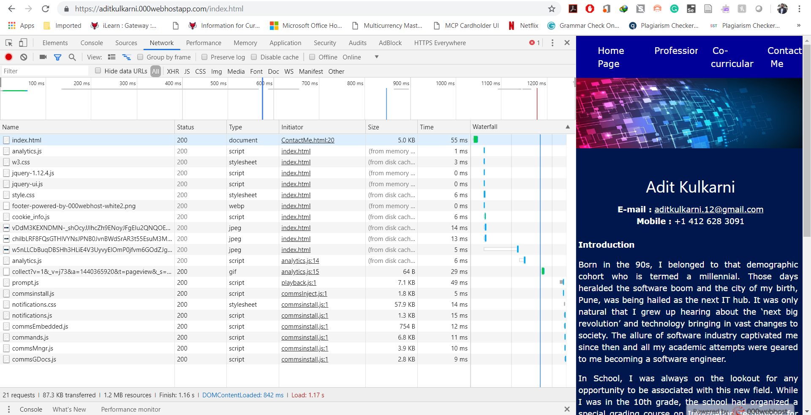

Professional -

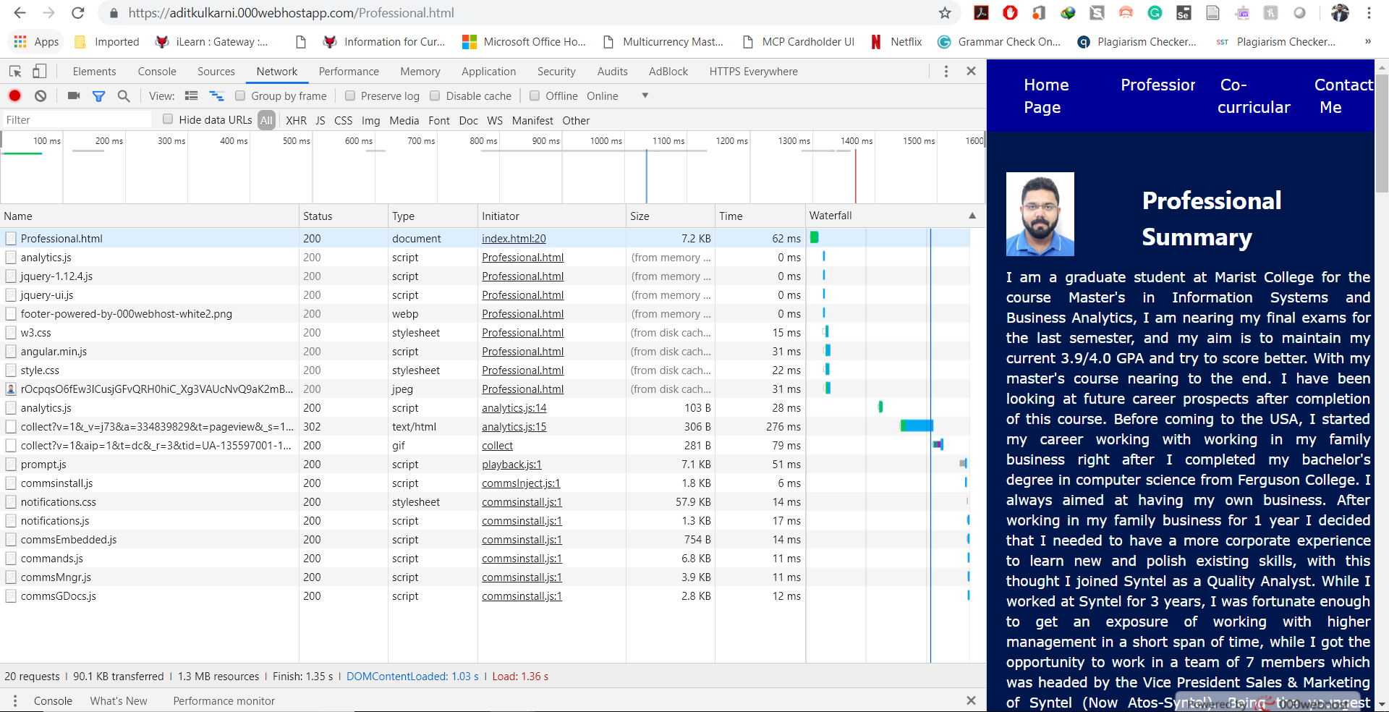

Co-curricular –

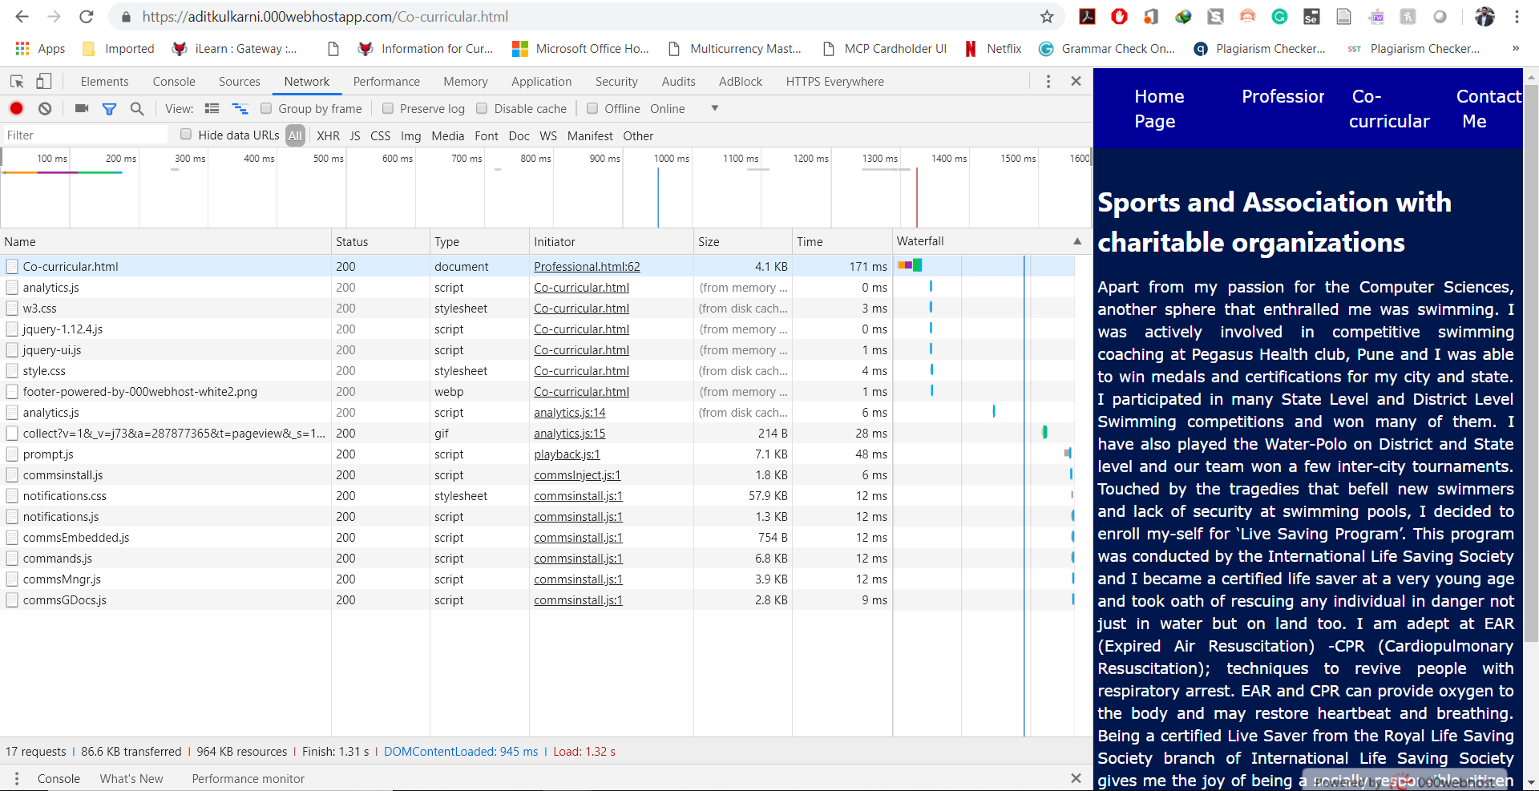

Contact Me –

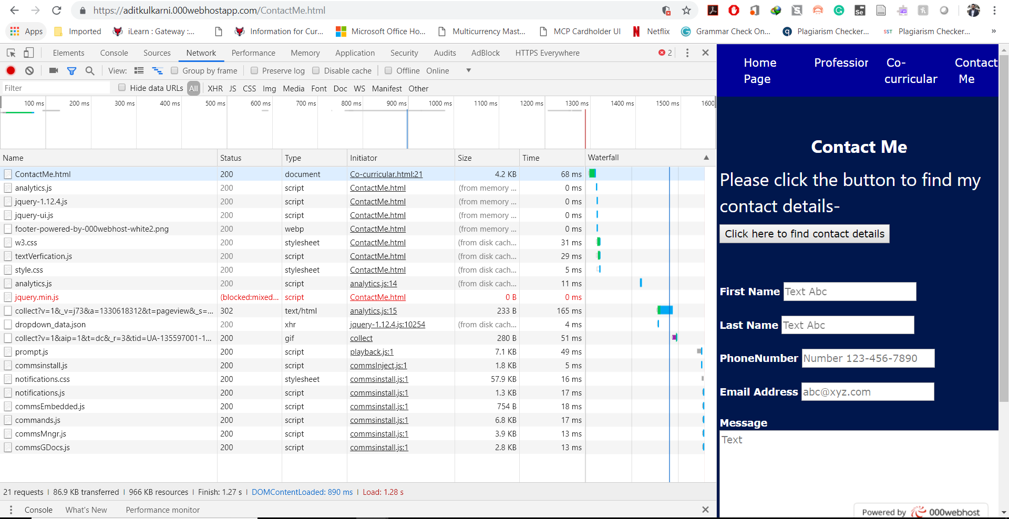

After making changes to code –

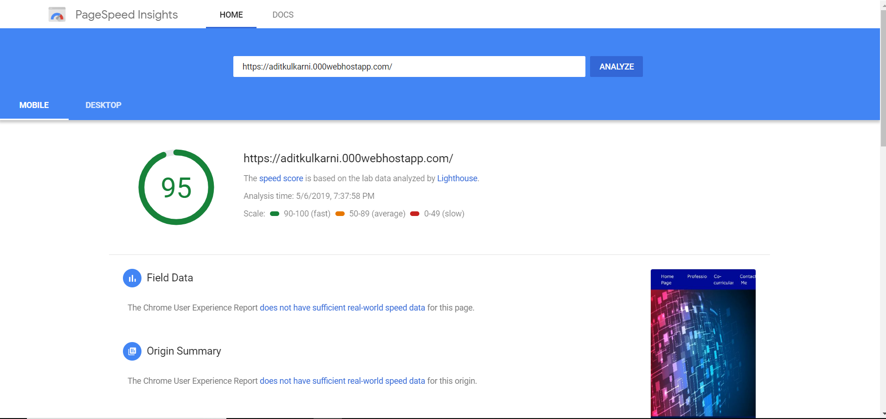

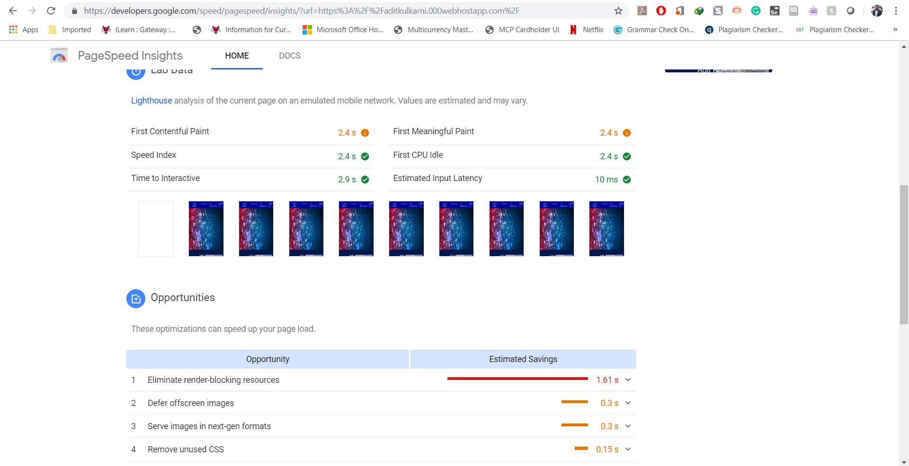

Network Tab Screenshots –

Home Page –

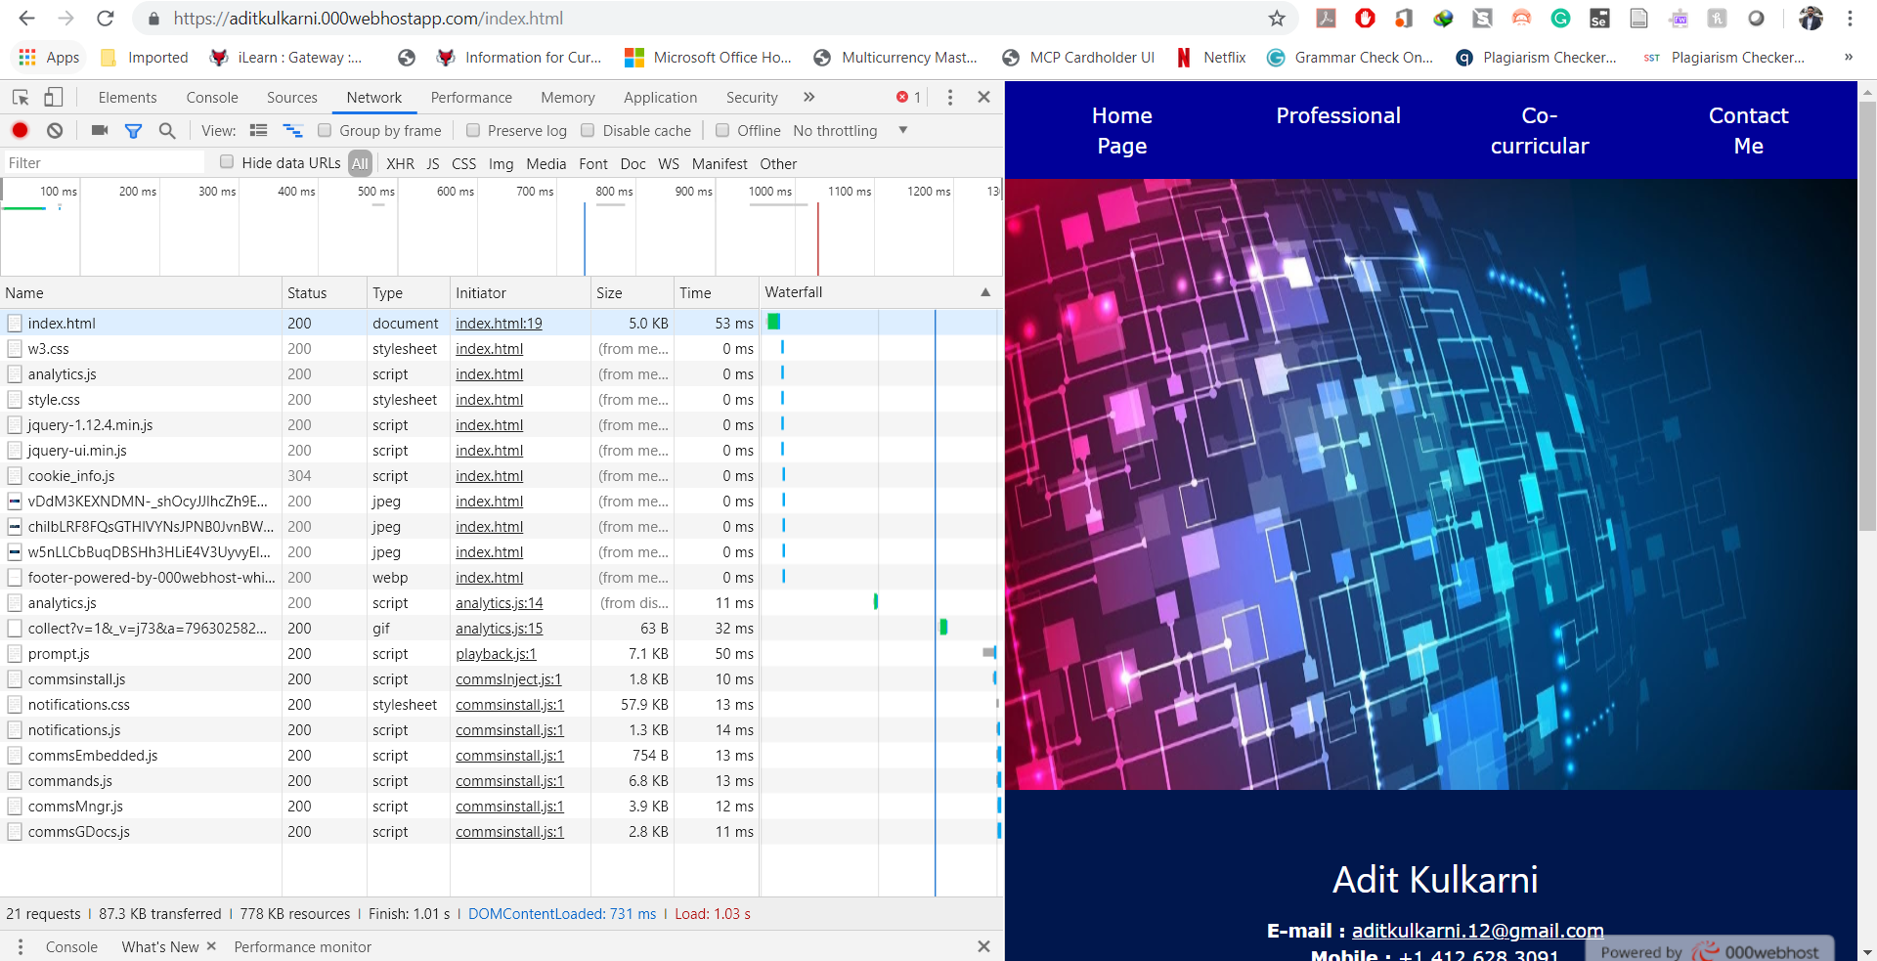

Professional –

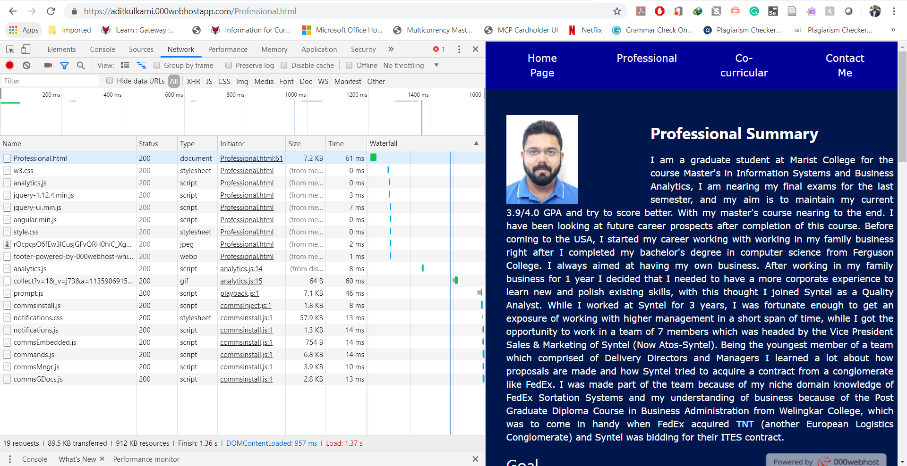

Co-curricular page -

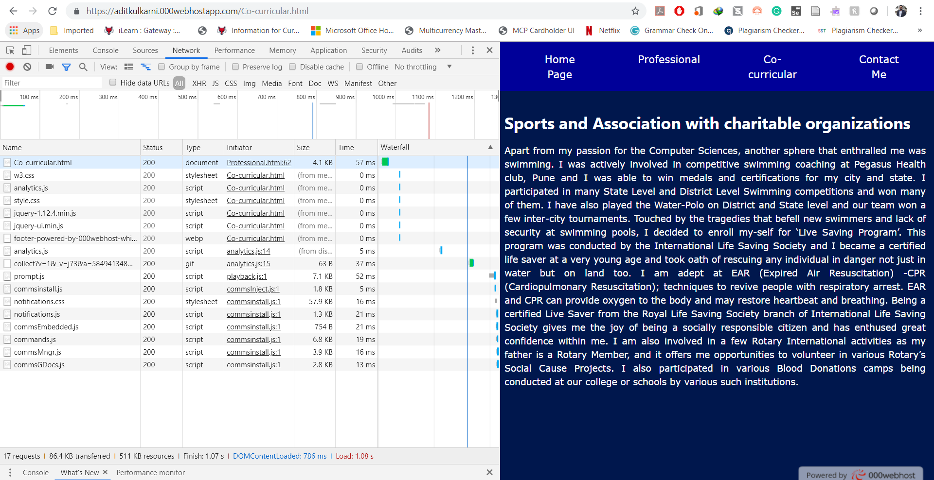

Contact me –

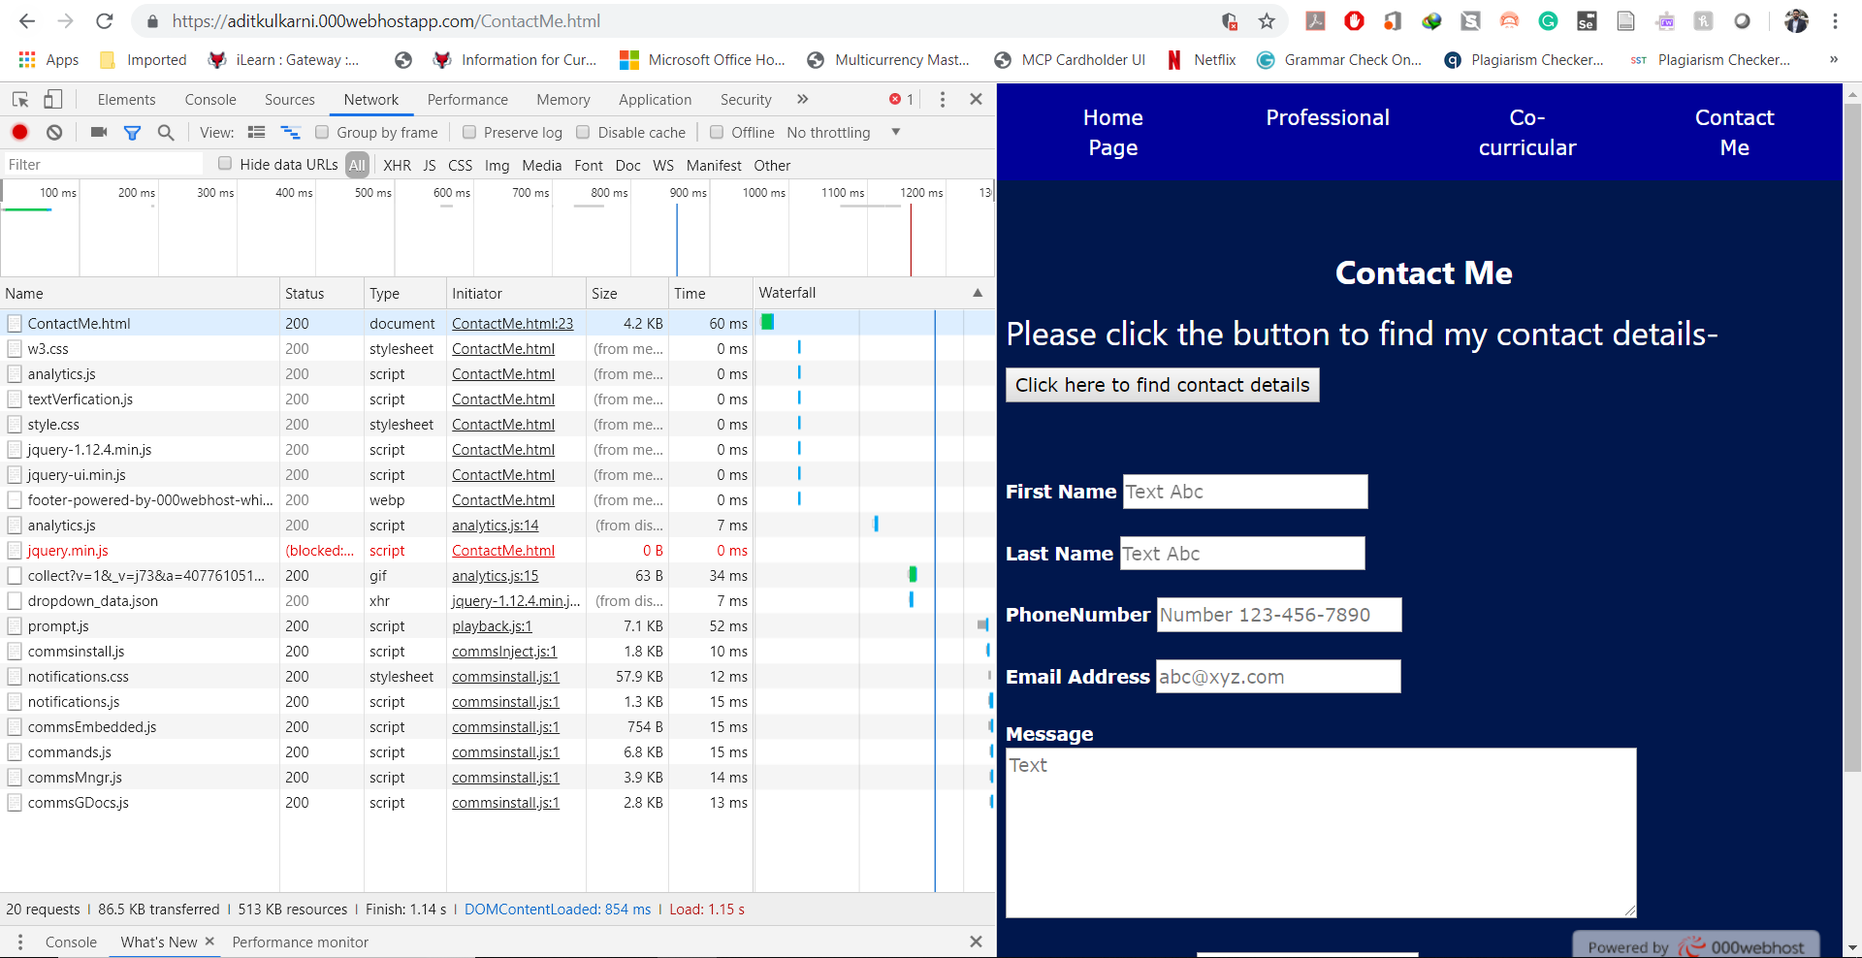

After Minifying the code –

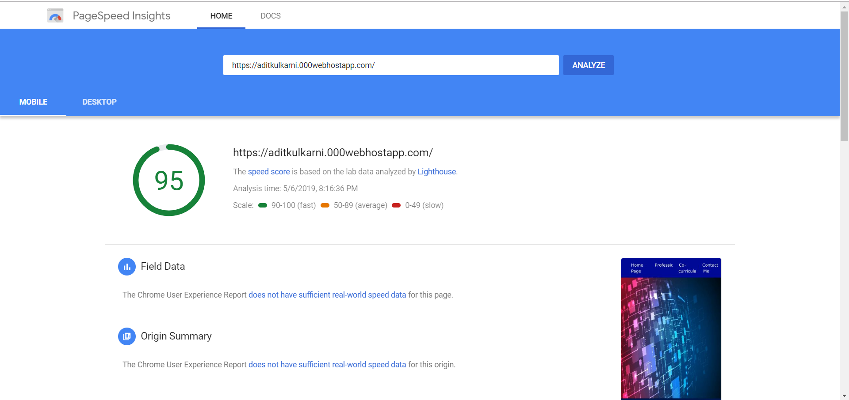

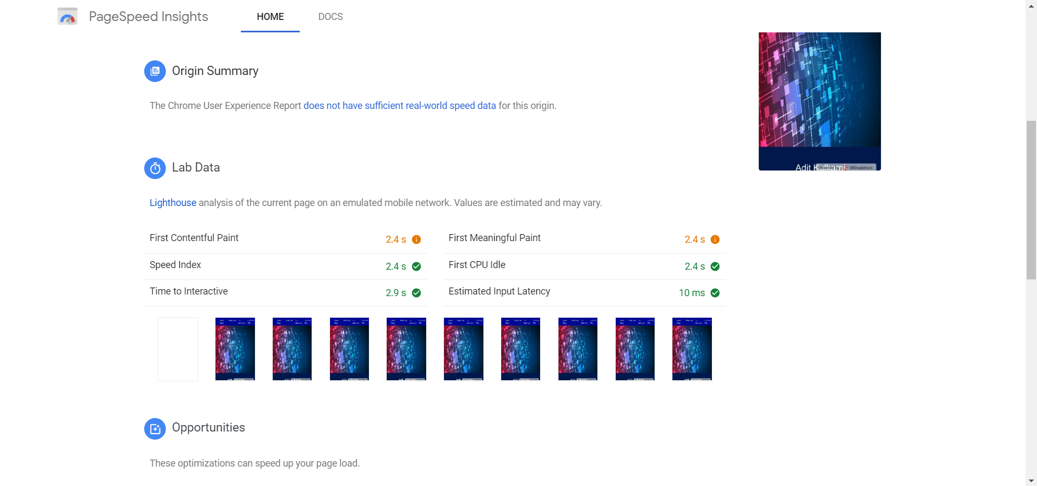

Developer Tools Network Tab –

Home page –

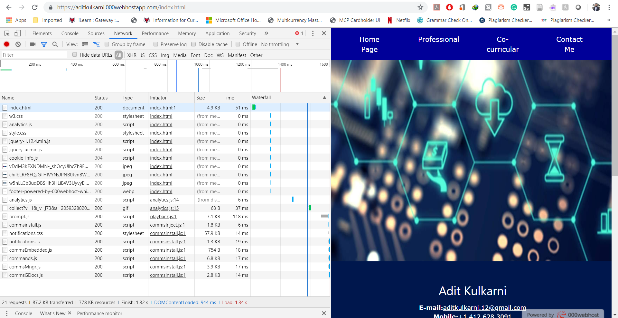

Professional –

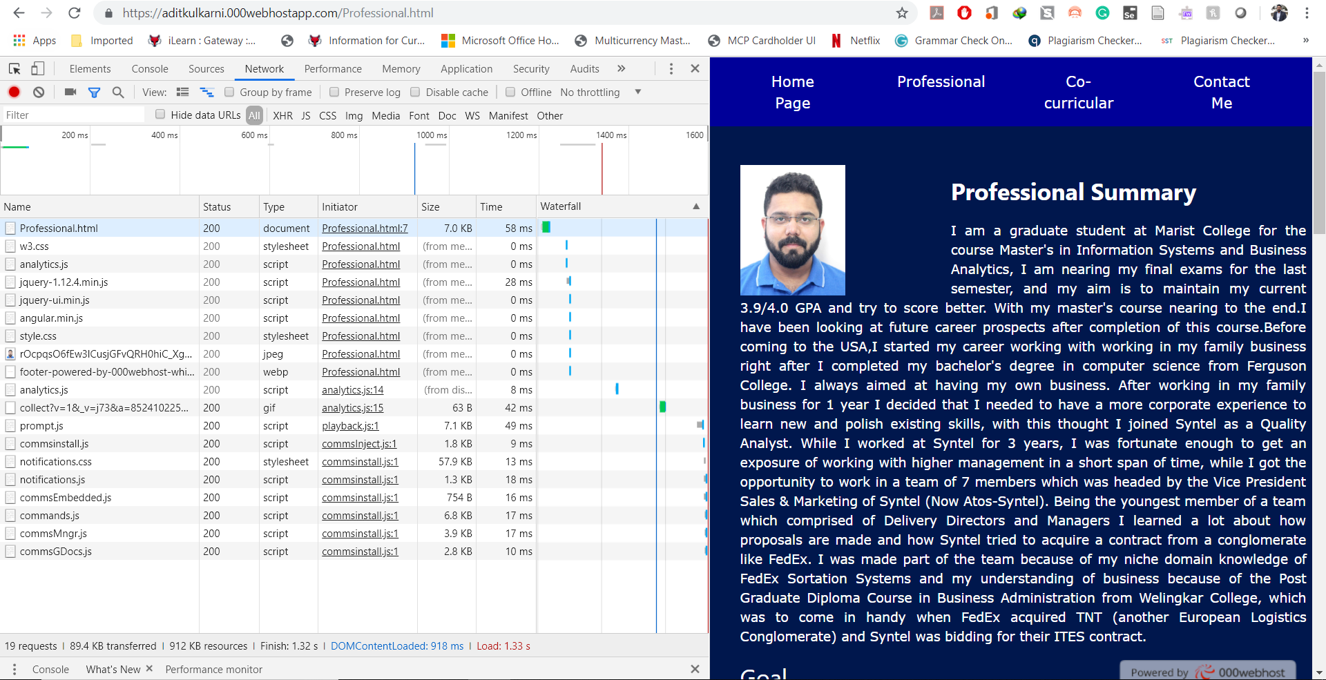

Co-curricular –

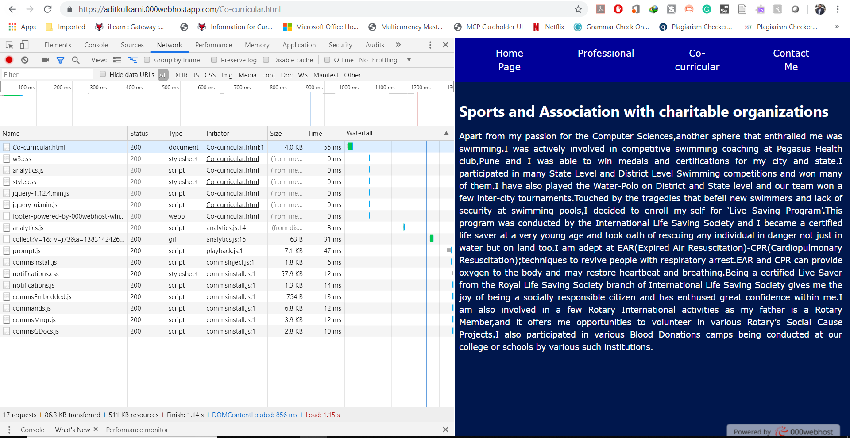

Contact Me –

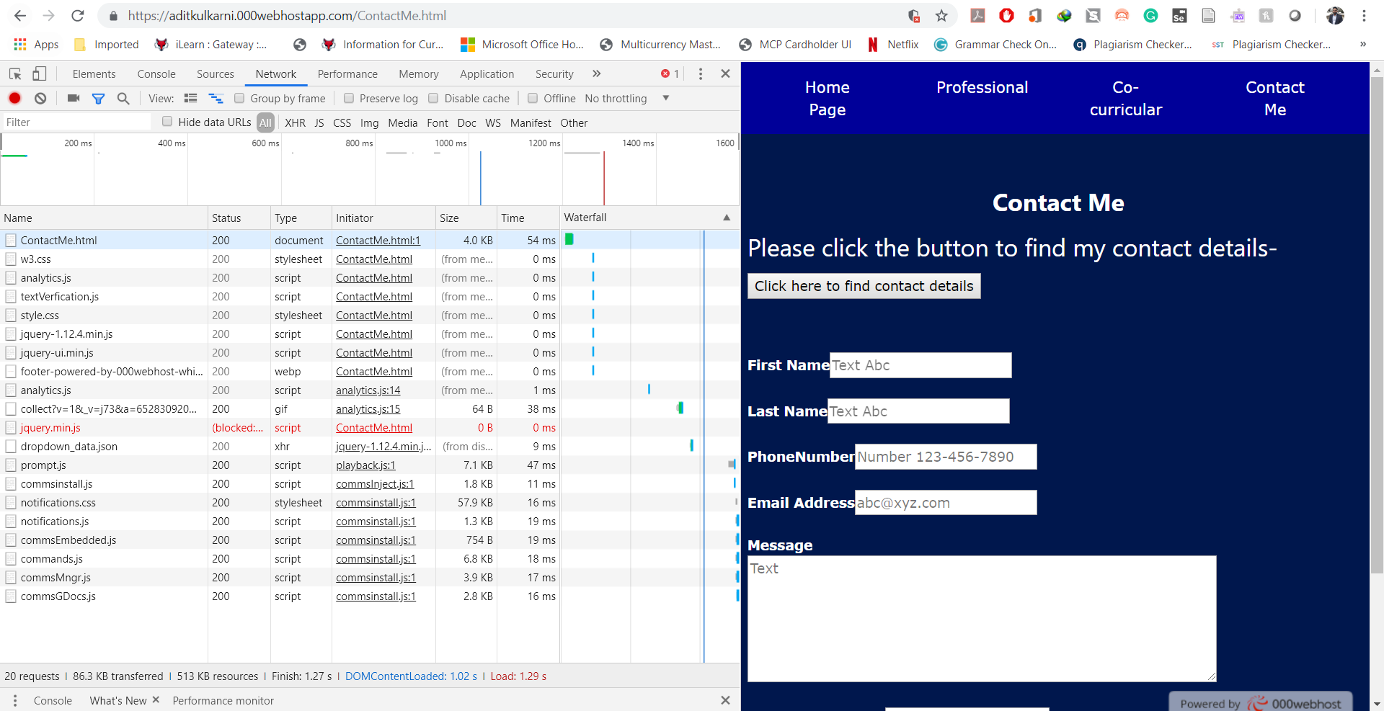

Questions –

1. How much of a performance increase were you able to gain by taking these simple actions?

Answer –

Initially my website score on Google PageSpeed Insights was 87, after adding the img size and making a few code changes in the for the script tag and css tag as mentioned in the assignment document I was able to increase the performance to 95 on Google PageSpeed Insights.

After minifying the code the score remained on 95 but the loading speed decreased in the Network Tab on Developer tools, the breakdown is given as follows –

|  |  |  |  |
| --- | --- | --- | --- |
| **Website Pages** | **Original Website** | **After making code changes** | **After Minifying the code** |
| Home Page | 55 | 53 | 51 |
| Professional | 62 | 61 | 58 |
| Co-Curricular | 171 | 57 | 55 |
| Contact Me | 68 | 60 | 54 |
| **Website Performance According to Google PageSpeed Insights** | **87** | **95** | **95** |